Virtual Training Center
Illinois Department of Children and Family Services
https://www.dcfstraining.org/vtc/home/home.action
At the completion of this course, you will need to print out your Certificate of Completion and send it to the Office of Human Resources at the Central Office to be included in your personnel file.

OR

Use the “Send Course Certificate” option and e-mail it to Suzy Ramos at mramos@geneva304.org.
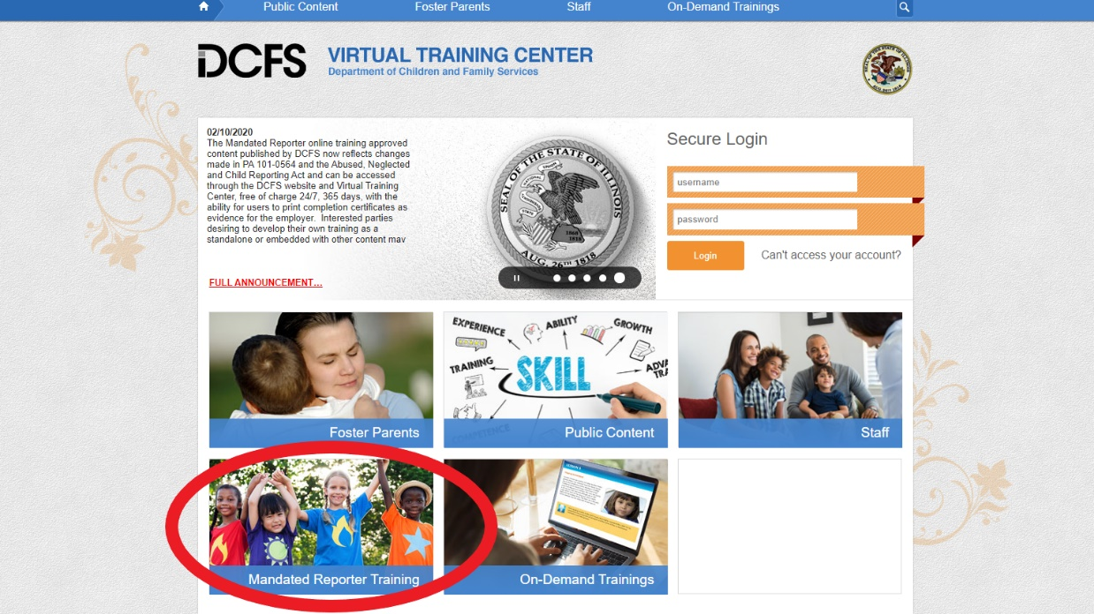
Click Mandated Reporter Training
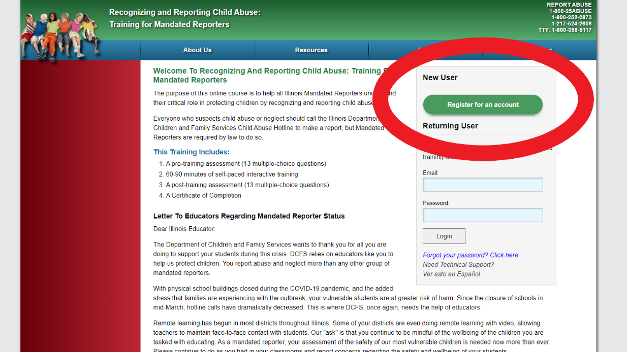
Register for an account

